Celebrating Football Through Photographs and Video

Recommended Guidelines

## Potential risks

The FA has developed this guidance to help avoid the following:

* The inappropriate use, adaptation or copying of images for use on child abuse websites on the internet (often incorrectly referred to as pornography sites)
* The identification of children when a photograph is accompanied by significant personal information that will assist a third party in identifying the child. This can lead, and has led, to children being ‘groomed’
* The identification and locating of children in inappropriate circumstances which include: (i) where a child has been removed from his/her family for their own safety; (ii) where restrictions on contact with one parent following a parental separation exist e.g. in domestic violence cases; (iii) in situations where

a child may be a witness in criminal proceedings; or (iv) other safeguarding children concerns.

It’s important to remember the majority of images taken are appropriate and taken in good faith. If we take the following simple measures we can help to ensure the safety of children in football.

## Common sense considerations to ensure everyone’s safety

**Do:**

There has been much talk about who is allowed to take pictures of children (under 18s) playing sport and in particular what parents/carers are permitted to do.

The FA would like to assure parents, carers, coaches, spectators, players and local media that we encourage the taking of appropriate images of children in football.

1. share The FA’s guidance on taking images with all parents, carers and members when they join the club
2. ensure the club has parental consent to use a player’s image if it is to be used in the public domain e.g.

club website or newspaper article. This is essential in relation to point 3 below

1. ensure that any child in your club who is under care proceedings, is protected by ensuring that their image is not placed in the public domain. This can be done by using a Consent Form, so that parents/carers can identify whether this applies to children in their care
2. focus on the activity rather than the individual
3. ensure all those featured are appropriately dressed (a minimum of vest or shirt and shorts)
4. aim to take pictures which represent the broad range of youngsters participating safely in football e.g. boys and girls, disabled people, ethnic minority communities.

**Don’t:**

1. publish photographs with the full name(s) of the individual(s) featured unless you have written consent to do so and you have informed the parents as to how the image will be used
2. use player profiles with pictures and detailed personal information on websites
3. use an image for something other than that which it was initially agreed, e.g. published in local press when initially produced for a clubhouse commemorative picture
4. allow images to be recorded in changing rooms, showers or toilets – this includes the use of mobile phones that record images.

## Filming as a coaching aid

The FA advises that coaches using videoing as a legitimate coaching aid should make parents/carers and players aware that this will be part of the coaching programme.

Care should be taken when storing the videos.

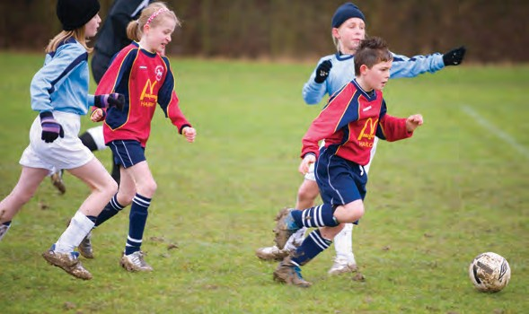

# TheFA.com/Footballsafe Let’s make football safe – not sorry

Celebrating Football Through Photographs and Video

## Commissioning professional photographers and the local media

If you are commissioning professional photographers or inviting the press to cover a football activity, ensure you and they are clear about each other’s expectations. The key is to plan ahead and communicate early on.

If you are concerned about the inappropriate use of images please report this to your CFA Welfare Officer or to The FA Case Manager (contact details provided below).

## Remember

* It’s not an offence to take appropriate photographs in a public place even if asked not to do so
* No one has the right to decide who can and cannot take images on public land
* If you have serious concerns about a possible child protection issue relating to the recording of images then call the Police. This action should only be taken where you believe that someone may be acting unlawfully or putting a child at risk
* The land or facility owner can decide whether or not photography and or videoing at football activities will be permitted when carried out on private land.

However, you need to make this known before allowing individuals access to the private property. If they do not comply then you may request that they leave

* Try not to use images that include individuals wearing jewellery (as wearing jewellery whilst playing is contrary to the Laws of the Game as well as being a health and safety issue).
* Provide a clear brief about what is considered appropriate in terms of content and behaviour
* Inform them of your club’s commitment to safeguarding children and young people. Establish who will hold

the recorded images and what they intend to do with them, e.g. place on a website for sale, distribute thumb nails to the club to co-ordinate sales

* Issue the professional photographer with identification, which must be worn at all times

Inform participants and parents or carers prior to the event that a professional photographer will be in attendance and ensure you have established that no under 18s will be compromised due to safeguarding children concerns if their image is taken – remember this can be done by using a Consent Form at the start of the season.

## To report potentially unlawful materials on the internet please contact:

**The Internet Watch Foundation** Email: [**report@iwf.org.uk**](mailto:report@iwf.org.uk)Telephone: **01223 237700**

Fax the hotline: **01223 235921** [**www.iwf.org.uk**](http://www.iwf.org.uk/)

**The FA’s Case Management Team** Email: [**case.management@TheFA.com**](mailto:case.management@TheFA.com)Telephone: **0207 745 4787**

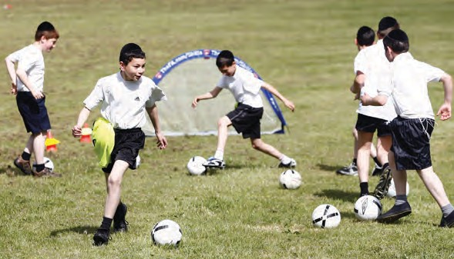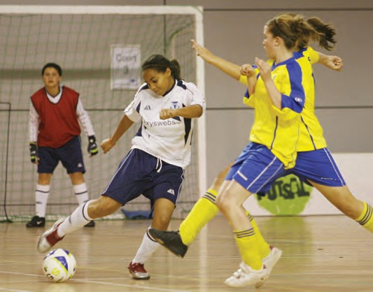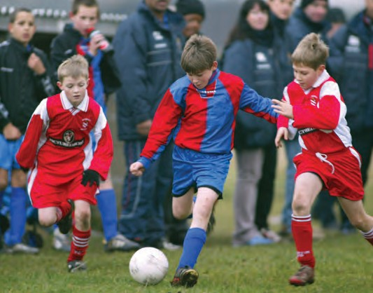

# TheFA.com/Footballsafe Let’s make football safe – not sorry